National University of Computer and Emerging Sciences, Karachi
FAST School of Computing
Re-Midterm II Examination, Spring 2022
18th May 2022, 09:00 am to 10:00 am
Course Code: CS3001 | Course Name: Computer Networks
Instructor Names: Dr. Farrukh Salim, Dr. Aqsa Aslam, Mr. Shoaib Raza and Ms. Eman Shahid
Student Roll No: |  | Section:
Instructions:-
- Return the question paper.
- All questions must be answered in the answer script and according to the sequence given in the question paper. There are 5 questions on 2 pages.
- In case of any ambiguity, you may make an assumption, however, your assumption should not contradict any statement in the question paper.
- Each question carries 10 points.
________________________________________________________________________________________
Time: 60 minutes Max Points: 50 points

Question 1:
Design a reliable data transfer protocol between the sender and receiver, operating over a channel that can lose or corrupt packets (data or ACKs). Specify the protocol using a finite state machine (FSM) for the sender side of the protocol.

Question 2:
(a) Draw a timeline diagram for the Selective Repeat algorithm with the sender's window sizes equal to 4. Assume at t=0, the sender sends packets 0, 1, 2 3 and packet 2 will be lost.

(b) How the below mentioned selective repeat dilemma can be resolved.
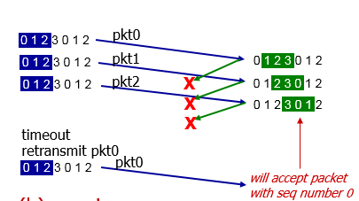
Figure 01: Selective Repeat Dilemma
Question 3:
Let’s suppose a window size of 4 and sequence number range from 0 to 8. Assume that 2nd packet in the window is lost. Apply TCP fast retransmission. Also, Generate Acknowledgements and complete the process until the lost packet is properly received by the receiver.

Question 4:
Suppose that TCP's current estimated values for the round trip time (estimated RTT) and deviation in the RTT (Deviation RTT) are 330 msec and 36 msec, respectively. Suppose that the next two measured values of the RTT are 330 msec, and 330 msec respectively. Compute TCP's new value of Deviaton RTT, estimated RTT, and the TCP timeout value after each of these two measured RTT values is obtained. Use the values of α = 0.125, and β = 0.25. Round your answers to two decimal places after leading zeros.

Question 5:
Consider figure 2, which plots the evolution of TCP's congestion window at the beginning of each time unit (where the unit of time is equal to the RTT); In the abstract model for this problem, TCP sends a "flight" of packets of size cwnd at the beginning of each time unit. The result of sending that flight of packets is that either (i) all packets are ACKed at the end of the time unit, (ii) there is a timeout for the first packet, or (iii) there is a triple duplicate ACK for the first packet. In this problem, you are asked to reconstruct the sequence of events (ACKs, losses) that resulted in the evolution of TCP's cwnd shown below.
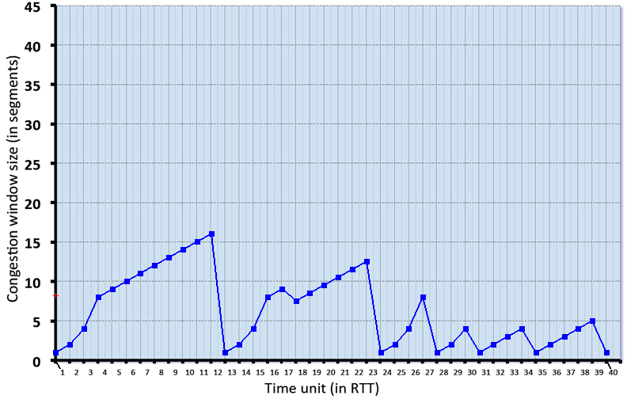

Figure 02: TCP Congestion Control

(a) Identify the time interval(s) during which TCP slow start and TCP congestion avoidance.
(b) Identify the time unit(s) (in RTT) at which packets are lost via timeout.
(c) Identify the time unit(s) (in RTT) at which packets are lost via triple ACK.
(d) In which transmission round 50th segment was sent.

Best of luck!

